**User Guide**

**Stakeholder Insights and Performance Dashboard**

**User Guide: Stakeholder Insights and Performance Dashboard**

**Purpose:**The dashboard provides a comprehensive view of key business metrics and data insights related to stakeholders, insurers, and policy performance. It enables stakeholders to analyse premium trends, profitability, and asset distribution to make data-driven decisions.

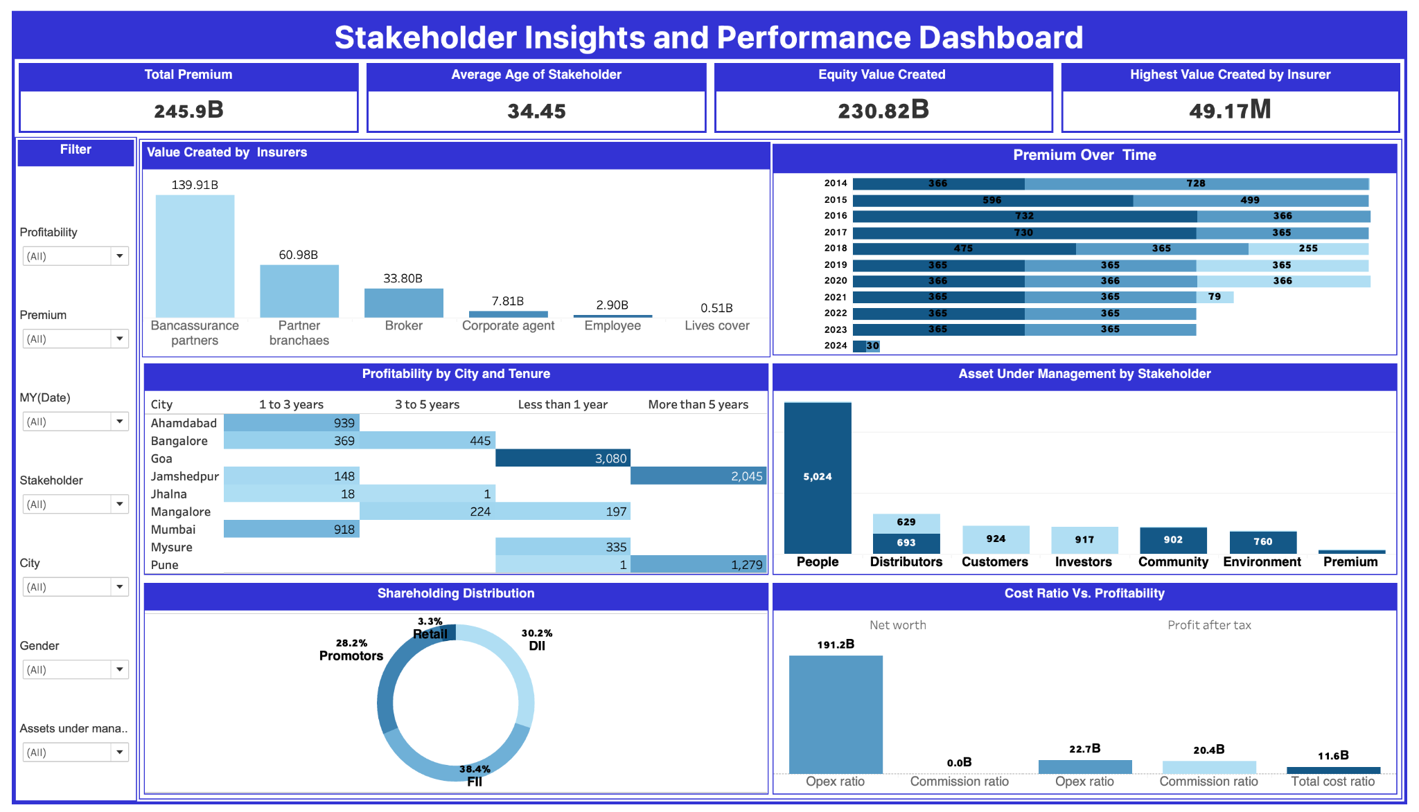

**Requirements:**

**1. Charts and Visualizations:**

* **Compare the total value created by different insurers**: Displays the total value created for a comparative analysis among insurers.
* **Display trends in premiums collected over time**: Shows premium trends using line or area charts to analyse changes over time.
* **Showcase the distribution of shareholding patterns among stakeholders**: Visualizes shareholding patterns using pie or bar charts.**Analyse the relationship between cost ratio and profitability**: Correlation or scatter plots reveal insights between cost ratio and profitability metrics.
* **Visualize profitability for different cities and policy tenure durations**: Heatmaps or bar charts categorize profitability by city and policy tenure.
* **Represent the distribution of assets under management across stakeholders**: Bar or treemap visualizations display how assets are distributed among stakeholders.

**2. Key Performance Indicators (KPIs):**

* **Display the total premium collected**: KPI card summarizing the total amount of premiums collected.
* **Show the average age of stakeholders**: KPI card presenting the average stakeholder age.
* **Highlight the total Value Created for insurers or stakeholders where Assets under Management is 'Equity'**: KPI card focusing on value creation under equity management.
* **Identify the highest value created by a single insurer**: KPI card showcasing the top-performing insurer by value created.

**3. Filters:**

* **Filter data by city**: Dropdown menu to focus data visualization on specific regions.
* **Filter data by stakeholders**: Dropdown to isolate and analyze individual stakeholder contributions.
* **Provide a range slider to filter policies based on tenure**: Interactive slider to set tenure ranges.
* **Allow filtering of data within a specific date range**: Date picker to narrow data analysis to a desired timeframe.
* **Enable filtering by gender for demographic insights**: Gender filter to separate male and female stakeholder data.

**4. Interactivity:**

* **Enable charts to dynamically filter other visuals when clicked**: Clicking a chart segment applies filters to other dashboard elements.
* **Provide tooltips on hover to display detailed information**: Rich tooltips reveal additional context, such as specific values or percentages.
* **Ensure filters and KPIs update dynamically based on selections**: All dashboard elements refresh based on applied filters or clicks.

**5. Export Options:**

* **PDF Export Button**: Dedicated button to download the dashboard as a PDF.
* **Ensure the PDF captures all visible charts, KPIs, and filters**: Export captures a snapshot of the current dashboard state.
* **Include a light watermark with the company's branding on the exported PDF**: Branding ensures a professional and consistent look.

**6. User Access:**

* **Role-based access**: Stakeholders with different roles have specific levels of data visibility.

**Usage Instructions:**

**Navigating the Dashboard:**

1. Use filters located at the top or side of the dashboard to refine data by city, tenure, date, stakeholder, or gender.
2. Interact with charts by clicking on segments to dynamically update other dashboard visuals.
3. Hover over any chart to view detailed tooltips for additional insights.

**Exporting Data:**

1. Click the **Export to PDF** button located in the toolbar.
2. Confirm the export options (e.g., filters and applied selections).
3. The PDF file will include all visible elements, KPIs, and filters, along with a light watermark.

**Accessing Role-Specific Data:**

1. Log in with your assigned credentials.
2. Your role determines the data you can view (e.g., insurers, stakeholders, policy data).

**Support and Contact:**

For technical assistance or feedback, please contact the dashboard support team at support@companydomain.com.